Eigenvalues
If the action of a matrix on a (nonzero) vector changes its magnitude but not its direction, then the vector is called an eigenvector of that matrix. A vector which is "flipped" to point in the opposite direction is also considered an eigenvector. Each eigenvector is, in effect, multiplied by a scalar, called the eigenvalue corresponding to that eigenvector. The eigenspace corresponding to one eigenvalue of a given matrix is the set of all eigenvectors of the matrix with that eigenvalue.
Many kinds of mathematical objects can be treated as vectors: ordered pairs, functions, harmonic modes, quantum states, and frequencies are examples. In these cases, the concept of direction loses its ordinary meaning, and is given an abstract definition. Even so, if this abstract direction is unchanged by a given linear transformation, the prefix "eigen" is used, as in eigenfunction, eigenmode, eigenstate, and eigenfrequency.
If a matrix is a diagonal matrix, then its eigenvalues are the numbers on the diagonal and its eigenvectors are basis vectors to which those numbers refer. For example, the matrix
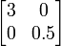
stretches every vector to three times its original length in the x-direction and shrinks every vector to half its original length in the y-direction. Eigenvectors corresponding to the eigenvalue 3 are any multiple of the basis vector [1, 0]; together they constitute the eigenspace corresponding to the eigenvalue 3. Eigenvectors corresponding to the eigenvalue 0.5 are any multiple of the basis vector [0, 1]; together they constitute the eigenspace corresponding to the eigenvalue 0.5. In contrast, any other vector, [2, 8] for example, will change direction. The angle [2, 8] makes with the x-axis has tangent 4, but after being transformed, [2, 8] is changed to [6, 4], and the angle that vector makes with the x-axis has tangent 2/3.
Linear transformations of a vector space, such as rotation, reflection, stretching, compression, shear or any combination of these, may be visualized by the effect they produce on vectors. In other words, they are vector functions. More formally, in a vector space L, a vector function A is defined if for each vector x of L there corresponds a unique vector y = A(x) of L. For the sake of brevity, the parentheses around the vector on which the transformation is acting are often omitted. A vector function A is linear if it has the following two properties:
- Additivity: A(x + y) = Ax + Ay
- Homogeneity: A(αx) = αAx
where x and y are any two vectors of the vector space L and α is any scalar.^{[12]} Such a function is variously called a linear transformation, linear operator, or linear endomorphism on the space L.

Definition | Given a linear transformation A, a non-zero vector x is defined to be an eigenvector of the transformation if it satisfies the eigenvalue equation  for some scalar λ. In this situation, the scalar λ is called an eigenvalue of A corresponding to the eigenvector x.^{[13]}
The key equation in this definition is the eigenvalue equation, Ax = λx. That is to say that the vector x has the property that its direction is not changed by the transformation A, but that it is only scaled by a factor of λ. Most vectors x will not satisfy such an equation: a typical vector x changes direction when acted on by A, so that Ax is not a multiple of x. This means that only certain special vectors x are eigenvectors, and only certain special scalars λ are eigenvalues. Of course, if A is a multiple of the identity matrix, then no vector changes direction, and all non-zero vectors are eigenvectors.
The requirement that the eigenvector be non-zero is imposed because the equation A0 = λ0 holds for every A and every λ. Since the equation is always trivially true, it is not an interesting case. In contrast, an eigenvalue can be zero in a nontrivial way. Each eigenvector is associated with a specific eigenvalue. One eigenvalue can be associated with several or even with an infinite number of eigenvectors.
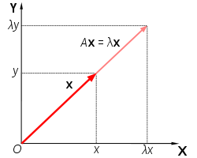
Fig. 2. A acts to stretch the vector x, not change its direction, so x is an eigenvector of A.
Geometrically (Fig. 2), the eigenvalue equation means that under the transformation A eigenvectors experience only changes in magnitude and sign—the direction of Ax is the same as that of x. The eigenvalue λ is simply the amount of "stretch" or "shrink" to which a vector is subjected when transformed by A. If λ = 1, the vector remains unchanged (unaffected by the transformation). A transformation I under which a vector x remains unchanged, Ix = x, is defined as identity transformation. If λ = −1, the vector flips to the opposite direction; this is defined as reflection.

If x is an eigenvector of the linear transformation A with eigenvalue λ, then any scalar multiple αx is also an eigenvector of A with the same eigenvalue. Similarly if more than one eigenvector shares the same eigenvalue λ, any linear combination of these eigenvectors will itself be an eigenvector with eigenvalue λ.^{[14]}. Together with the zero vector, the eigenvectors of A with the same eigenvalue form a linear subspace of the vector space called an eigenspace.
The eigenvectors corresponding to different eigenvalues are linearly independent^{[15]} meaning, in particular, that in an n-dimensional space the linear transformation A cannot have more than n eigenvectors with different eigenvalues.^{[16]}
If a basis is defined in vector space, all vectors can be expressed in terms of components. For finite dimensional vector spaces with dimension n, linear transformations can be represented with n × n square matrices. Conversely, every such square matrix corresponds to a linear transformation for a given basis. Thus, in a two-dimensional vector space R² fitted with standard basis, the eigenvector equation for a linear transformation A can be written in the following matrix representation:
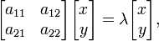
where the juxtaposition of matrices denotes matrix multiplication.
A matrix is said to be defective if it fails to have n linearly independent eigenvectors. All defective matrices have fewer than n distinct eigenvalues, but not all matrices with fewer than n distinct eigenvalues are defective.^{[17}

Computation of eigenvalues, and the characteristic equation
When a transformation is represented by a square matrix A, the eigenvalue equation can be expressed as
This can be rearranged to
If there exists an inverse
then both sides can be left multiplied by the inverse to obtain the trivial solution: x = 0. Thus we require there to be no inverse by assuming from linear algebra that the determinant equals zero:
det(A − λI) = 0.
The determinant requirement is called the characteristic equation (less often, secular equation) of A, and the left-hand side is called the characteristic polynomial. When expanded, this gives a polynomial equation for λ. The eigenvector x or its components are not present in the characteristic equation.
The matrix
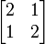
defines a linear transformation of the real plane. The eigenvalues of this transformation are given by the characteristic equation
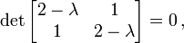
The roots of this equation (i.e. the values of λ for which the equation holds) are λ = 1 and λ = 3. Having found the eigenvalues, it is possible to find the eigenvectors. Considering first the eigenvalue λ = 3, we have
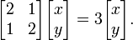
After matrix-multiplication 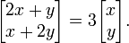
This matrix equation represents a system of two linear equations 2x + y = 3x and x + 2y = 3y. Both the equations reduce to the single linear equation x = y. To find an eigenvector, we are free to choose any value for x (except 0), so by picking x=1 and setting y=x, we find an eigenvector with eigenvalue 3 to be
We can confirm this is an eigenvector with eigenvalue 3 by checking the action of the matrix on this vector:
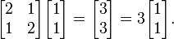
Any scalar multiple of this eigenvector will also be an eigenvector with eigenvalue 3.
For the eigenvalue λ = 1, a similar process leads to the equation x = − y, and hence an eigenvector with eigenvalue 1 is given by
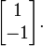
The complexity of the problem for finding roots/eigenvalues of the characteristic polynomial increases rapidly with increasing the degree of the polynomial (the dimension of the vector space). There are exact solutions for dimensions below 5, but for dimensions greater than or equal to 5 there are generally no exact solutions and one has to resort to numerical methods to find them approximately. Worse, this computational procedure can be very inaccurate in the presence of round-off error, because the roots of a polynomial are an extremely sensitive function of the coefficients (see Wilkinson's polynomial).^{[18]} Efficient, accurate methods to compute eigenvalues and eigenvectors of arbitrary matrices were not known until the advent of the QR algorithm in 1961.^{[18]} For large Hermitian sparse matrices, the Lanczos algorithm is one example of an efficient iterative method to compute eigenvalues and eigenvectors, among several other possibilities.^{[18]}

Jacobian
In vector calculus, the Jacobian matrix is the matrix of all first-order partial derivatives of a vector-valued function. Suppose F : R^{n} → R^{m} is a function from Euclidean n-space to Euclidean m-space. Such a function is given by m real-valued component functions, y₁(x₁,...,x_{n}), ..., y_{m}(x₁,...,x_{n}). The partial derivatives of all these functions (if they exist) can be organized in an m-by-n matrix, the Jacobian matrix J of F, as follows:
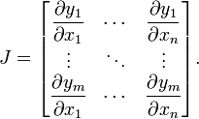
This matrix is also denoted by and 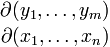. The i th row (i = 1, ..., m) of this matrix is the gradient of the i^{th} component function y_{i}: .
The Jacobian determinant (often simply called the Jacobian) is the determinant of the Jacobian matrix.
The Jacobian of a function describes the orientation of a tangent plane to the function at a given point. In this way, the Jacobian generalizes the gradient of a scalar valued function of multiple variables which itself generalizes the derivative of a scalar-valued function of a scalar. Likewise, the Jacobian can also be thought of as describing the amount of "stretching" that a transformation imposes. For example, if (x₂,y₂) = f(x₁,y₁) is used to transform an image, the Jacobian of f, J(x₁,y₁) describes how much the image in the neighborhood of (x₁,y₁) is stretched in the x, y, and xy directions.
If a function is differentiable at a point, its derivative is given in coordinates by the Jacobian, but a function doesn't need to be differentiable for the Jacobian to be defined, since only the partial derivatives are required to exist.
The importance of the Jacobian lies in the fact that it represents the best linear approximation to a differentiable function near a given point. In this sense, the Jacobian is the derivative of a multivariate function. For a function of n variables, n > 1, the derivative of a numerical function must be matrix-valued, or a partial derivative.
If p is a point in R^{n} and F is differentiable at p, then its derivative is given by J_{F}(p). In this case, the linear map described by J_{F}(p) is the best linear approximation of F near the point p, in the sense that
for x close to p and where o is the little o-notation (for , not ) and is the distance between x and p.
In a sense, both gradient and Jacobian are "first derivatives", the former of a scalar function of several variables and the latter of a vector function of several variables. Jacobian of the gradient has a special name: the Hessian matrix which in a sense is the "second derivative" of the scalar function of several variables in question. (More generally, gradient is a special version of Jacobian; it is the Jacobian of a scalar function of several variables.)
According to the inverse function theorem, the matrix inverse of the Jacobian matrix of a function is the Jacobian matrix of the inverse function. That is, for some function F : R^{n} → R^{n} and a point p in R^{n},
.
It follows that the (scalar) inverse of the Jacobian determinant of a transformation is the Jacobian determinant of the inverse transformation.
Example 1. The transformation from spherical coordinates (r, θ, φ) to Cartesian coordinates (x₁, x₂, x₃) is given by the function F : R⁺ × [0,π) × [0,2π) → R³ with components:
The Jacobian matrix for this coordinate change is
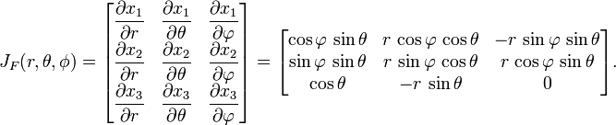
Example 2. The Jacobian matrix of the function F : R³ → R⁴ with components
is
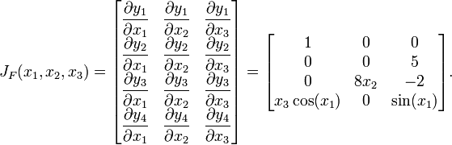
This example shows that the Jacobian need not be a square matrix.
Consider a dynamical system of the form x' = F(x), where x' is the (component-wise) time derivative of x, and F : R^{n} → R^{n} is continuous and differentiable. If F(x₀) = 0, then x₀ is a stationary point (also called a fixed point). The behavior of the system near a stationary point is related to the eigenvalues of J_{F}(x₀), the Jacobian of F at the stationary point.^{[1]} Specifically, if the eigenvalues all have magnitude less than one, then the point is an attractor, but if any eigenvalue has magnitude greater than one, then the point is unstable.
If m = n, then F is a function from n-space to n-space and the Jacobian matrix is a square matrix. We can then form its determinant, known as the Jacobian determinant. The Jacobian determinant is also called the "Jacobian" in some sources.
The Jacobian determinant at a given point gives important information about the behavior of F near that point. For instance, the continuously differentiable function F is invertible near a point p ∈ R^{n} if the Jacobian determinant at p is non-zero. This is the inverse function theorem. Furthermore, if the Jacobian determinant at p is positive, then F preserves orientation near p; if it is negative, F reverses orientation. The absolute value of the Jacobian determinant at p gives us the factor by which the function F expands or shrinks volumes near p; this is why it occurs in the general substitution rule.
The Jacobian determinant of the function F : R³ → R³ with components
is
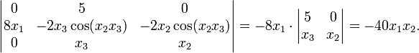
From this we see that F reverses orientation near those points where x₁ and x₂ have the same sign; the function is locally invertible everywhere except near points where x₁ = 0 or x₂ = 0. Intuitively, if you start with a tiny object around the point (1,1,1) and apply F to that object, you will get an object set with approximately 40 times the volume of the original one.
The Jacobian determinant is used when making a change of variables when integrating a function over its domain. To accommodate for the change of coordinates the Jacobian determinant arises as a multiplicative factor within the integral. Normally it is required that the change of coordinates is done in a manner which maintains an injectivity between the coordinates that determine the domain. The Jacobian determinant, as a result, is usually well defined.
Hessian matrix
In mathematics, the Hessian matrix (or simply the Hessian) is the square matrix of second-order partial derivatives of a function; that is, it describes the local curvature of a function of many variables. The Hessian matrix was developed in the 19th century by the German mathematician Ludwig Otto Hesse and later named after him. Hesse himself had used the term "functional determinants".
Given the real-valued function
if all second partial derivatives of f exist, then the Hessian matrix of f is the matrix
where x = (x₁, x₂, ..., x_{n}) and D_{i} is the differentiation operator with respect to the ith argument and the Hessian becomes
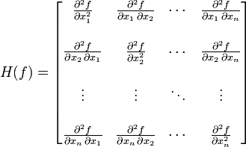
Some mathematicians define the Hessian as the determinant of the above matrix.
Hessian matrices are used in large-scale optimization problems within Newton-type methods because they are the coefficient of the quadratic term of a local Taylor expansion of a function. That is,
where J is the Jacobian matrix, which is a vector (the gradient) for scalar-valued functions. The full Hessian matrix can be difficult to compute in practice; in such situations, quasi-Newton algorithms have been developed that use approximations to the Hessian. The most well-known quasi-Newton algorithm is the BFGS algorithm.

Mixed derivatives and symmetry of the Hessian
The mixed derivatives of f are the entries off the main diagonal in the Hessian. Assuming that they are continuous, the order of differentiation does not matter (Clairaut's theorem). For example,
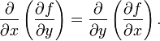
This can also be written (in reverse order) as:
In a formal statement: if the second derivatives of f are all continuous in a neighborhood, D, then the Hessian of f is a symmetric matrix throughout D; see symmetry of second derivatives.

Critical points and discriminant
If the gradient of f (i.e. its derivative in the vector sense) is zero at some point x, then f has a critical point (or stationary point) at x. The determinant of the Hessian at x is then called the discriminant. If this determinant is zero then x is called a degenerate critical point of f, this is also called a non-Morse critical point of f. Otherwise it is non-degenerate, this is called a Morse critical point of f.

Second derivative test
The following test can be applied at a non-degenerate critical point x. If the Hessian is positive definite at x, then f attains a local minimum at x. If the Hessian is negative definite at x, then f attains a local maximum at x. If the Hessian has both positive and negative eigenvalues then x is a saddle point for f (this is true even if x is degenerate). Otherwise the test is inconclusive.
Note that for positive semidefinite and negative semidefinite Hessians the test is inconclusive (yet a conclusion can be made that f is locally convex or concave respectively). However, more can be said from the point of view of Morse theory.
In view of what has just been said, the second derivative test for functions of one and two variables is simple. In one variable, the Hessian contains just one second derivative; if it is positive then x is a local minimum, if it is negative then x is a local maximum; if it is zero then the test is inconclusive. In two variables, the discriminant can be used, because the determinant is the product of the eigenvalues. If it is positive then the eigenvalues are both positive, or both negative. If it is negative then the two eigenvalues have different signs. If it is zero, then the second derivative test is inconclusive.

Bordered Hessian
A bordered Hessian is used for the second-derivative test in certain constrained optimization problems. Given the function as before:
but adding a constraint function such that:
the bordered Hessian appears as
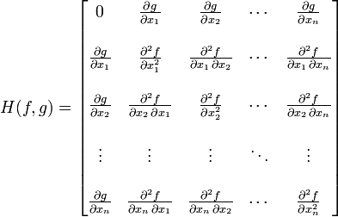
If there are, say, m constraints then the zero in the north-west corner is an m × m block of zeroes, and there are m border rows at the top and m border columns at the left.
The above rules of positive definite and negative definite can not apply here since a bordered Hessian can not be definite: we have z'Hz = 0 if vector z has a non-zero as its first element, followed by zeroes.
The second derivative test consists here of sign restrictions of the determinants of a certain set of n - m submatrices of the bordered Hessian^{[1]}. Intuitively, think of the m constraints as reducing the problem to one with n - m free variables. (For example, the maximization of f(x₁,x₂,x₃) subject to the constraint x₁ + x₂ + x₃ = 1 can be reduced to the maximization of f(x₁,x₂,1 − x₁ − x₂) without constraint.)

POSITIVE DEFINITE
An n × n real symmetric matrix M is positive definite if z^{T}Mz > 0 for all non-zero vectors z with real entries (), where z^{T} denotes the transpose of z.
For complex matrices, this definition becomes: a Hermitian matrix M is positive definite if z*Mz > 0 for all non-zero complex vectors z, where z* denotes the conjugate transpose of z. The quantity z*Mz is always real because M is a Hermitian matrix. For this reason, positive-definite matrices are often defined to be Hermitian matrices satisfying z*Mz > 0 for non-zero z. The section Non-Hermitian matrices discusses the consequences of dropping the requirement that M be Hermitian.
The matrix 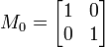is positive definite. For a vector with entries 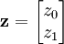the quadratic
form is 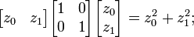when the entries z₀, z₁ are real and at least one of
them nonzero, this is positive.
The matrix 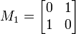is not positive definite. When 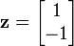the quadratic form at z is then
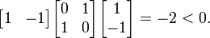
Another example of positive definite matrix is given by
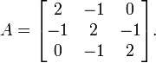
It is positive definite since for any non-zero vector 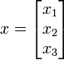, we have
